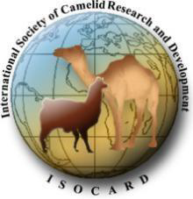

International Society of Camelid Research and Development (ISOCARD)

Letter to organisations interested in hosting the seventh ISOCARD international conference
ISOCARD invites expressions of interest from international research organisations, academic or industrial institutions to host the 2026 ISOCARD international conference. The 2026 ISOCARD international conference will be the seventh in a series of meetings which bring camelid scientists together to meet and share their research outcomes and provide updates and highlights on advancements and achievements in camelid research. The first meeting was held in UAE in 2006, followed by the following meetings: 2009 in Tunisia, 2012 in Oman, 2015 in Kazakhstan, 2018 in Morocco, and 2023 in Saudia Arabia.
Interested organisations are asked to complete the application form and clearly specify the conference themes, specific objectives, and all other information that should be included.
The provided information will assist the members of the ISOCARD Executive Committee to review the applications and make their decision. Proposals should be submitted by September 30, 2025, for consideration by the Executive Committee of ISOCARD via the email addresses provided in the application.
Looking forward to receiving your application.
Regards
Rafat Al Jassim
Chairman, ISOCAR

